**GIT commands that are important to learn to use command line.**

**Make a folder go inside it and right click open git bash**

**git –version**

**git init 🡪to initialize the folder**

1. **git config --global user.name** **aks** – For configuring the name
2. **git config --global user.email** [**anandkrishna2911@gmail.com**](mailto:anandkrishna2911@gmail.com) – to set the email
3. **git config --global user.name** – For checking the changes have been affected
4. **git config** **--global user.email** - For checking the changes have been affected

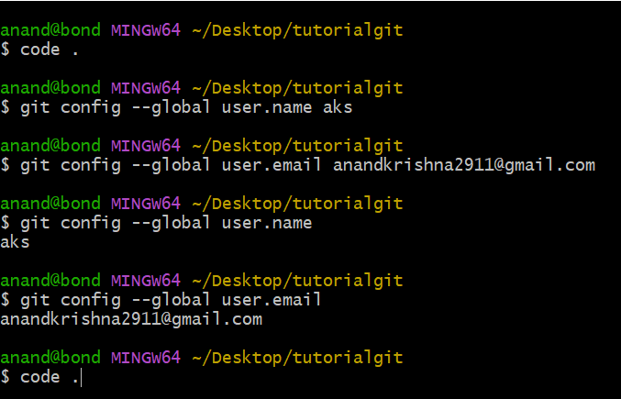

1. **code .** – to open the VS Code
2. **git init** – initialize the git repository
3. **ls -lart** – To see the Hidden files

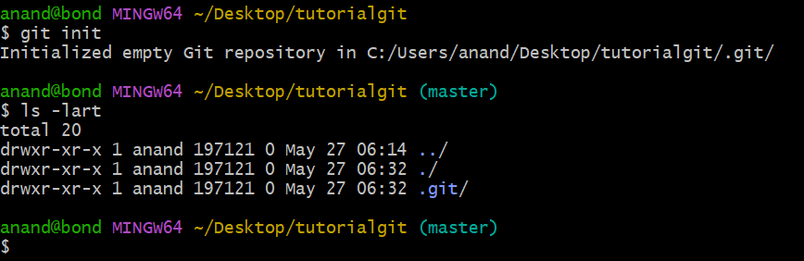

1. **git status** – To check the status of the files
2. **touch about.html**- create a blank about.html file (edit in vscode html:5🡪edit title “About Page”🡪edit body “This is About Page”)
3. **touch news.html** -create a blank news.html file (edit in vscode html:5🡪edit title “News Page”🡪edit body “This is News Page”)
4. **git status**
5. **git add about.html** – To add to the staging area
6. **git status**
7. **git add –A –>** To add all files in staging area
8. **git status**
9. **git commit –m “The First Commit” –** To commit along with message
10. **\*\*GoTo VS code and delete the contents of about.html and news.html and save**
11. **clear** – to clear the previous files
12. **git checkout about.html** – To match the file with last commit
13. **git checkout news.html** – To match the file with last commit
14. **\*\*GoTo VS code and delete the contents of about.html and news.html and save**
15. **git checkout -f** – All files get matched to the previous files
16. **git log** – to check the activity of the files, all the commits are shown and config files
17. **git log -p -1**– to see he last 1 commits on the machine and shows the changes we made
18. **press q to quit**
19. **touch contact.html**- create a blank contact.html file (edit in vscode html:5🡪edit title “Contact Form🡪edit body “This is contact Page”)
20. **git status**
21. **git add .**
22. **git status**
23. **GoTo VS code and edit and append the contents of news.html in body section <h1>This is New Feature</h1>**

**save**

1. **git status**
2. **git add –A**
3. **GoTo VS code and edit and append the contents of about.html in body section <h1>This is New Feature</h1>**
4. **GoTo VS code and edit and append the contents of contact.html in body section <h1>This is New Feature</h1>**

**save**

1. **git status**
2. **git add –A**
3. **git commit -m “Adding the new features to files”**
4. **GoTo VS code and edit and append the contents of about.html in body section <h1>This is New Feature</h1>**

**save**

1. **GoTo VS code and edit and append the contents of contact.html in body section <h1>This is New Feature</h1>**

**save**

1. **clear**
2. **git status**
3. **git commit -a -m “skipped staging area”** -If you wat to directly commit the file without making it to the staging area.
4. **git log -p -2**– to see he last 2 commits on the machine and shows the changes we made
5. **ls**
6. **touch delete.html -**to create a blank delete.html file (edit in vscode html:5🡪edit title “Delete File🡪edit body “This is Waste Page”) save
7. **git status**
8. **git add -A**
9. **git status**
10. **git rm –cached delete.html** – it will remove from staging area only not from hard disk it will become untracked
11. **clear**
12. **git status**
13. **git add –A**
14. **git commit -m “This is waste file”**
15. **git status**
16. **git log –p -1**
17. **git rm –cached delete.html**
18. **git commit -m “Deleted the waste file delete.html”**
19. **git rm –f delete.html** -If you want to delete a file from hard disk also
20. **git commit -a -m “Removed Delete.html”**
21. **git log -p -2** – If you want to see 2 commits
22. **git status -s** – shows the summarized status (modify the file then use this command )
23. **GoTo VS code and edit and append the contents of contact.html in body section <h1>This is New Feature</h1>**

**save**

1. **git status –s 🡪** **s** is for summary
2. **git add –A**
3. **git status -s** 🡪 shows the m in green